Energetic Exchange

A Transitional Tool.
From Fiat to Freedom.

“EasE”

Energetic Exchange or “EasE” was created as a transitional tool to escape our current fiat money system. EasE does have a value based on the current Canadian dollar ($1 dollar = 1 minute) so it can be easily exchanged back and forth, however EasE itself is not based on dollars. EasE is a time-based currency or exchange system that avoids things like inflation and manipulated fluctuations of its value. While time can feel fast or slow most of us can agree that an hour is an hour. Being time based it removes the current money systems immense injustice of one person being worth more per hour than another, all are equal under EasE. Having said that there is also the option of paying someone an hour for only a half hour of creation or any other agreement two parties may come to. An example of this would be if someone could do a task twice as fast as another, they may agree to pay an hour for only 30 minutes work. Another example would be that someone simply agrees that a certain task is worth more to them than the time it actually took. Having flexibility in this way will help people transition more easily from the current money system where one’s effort can be valued much higher than another’s effort over the same amount of time. An example of this would be a janitor making $15 an hour compared to a lawyer making $250 an hour.

1,000 years ago in England the Tally-stick was created to try and escape the moneychangers system. They knew that for this to work there had to be something backing it and there needed to be places to use it. The then King of England, Henry the First give the Talley-stick value by allowing taxes to be paid with it, and while I believe taxes are theft, it did give the Talley-stick value. While EasE inherently has the value of the person’s time and energy behind it, it will also need a value associated with the current system if it is to work as a transitional tool. To give EasE that value it will be accepted for every single aspect and creation in and of Talking Trees, from a 13-month calendar to a Holistic Home loan. To add further value, we will be working directly with local first nations who have developed the Wampum as an alternative currency. The hope is the Wampum and EasE will carry the same value and be traded equally as well as being able to be spent at any place or on any item the other is accepted. Like the earth and the experience of time itself this exchange system is borderless, so while EasE may originate and be first used by Talking Trees and the area some refer to as North Frontenac nothing is stopping this exchange system from being used anywhere and everywhere.

To create the 7 physical 55mil x 144mil notes for EasE we will be using a recycled plastic, organic hemp blend and printing them at Talking Trees as a community project. I would like to say that the creation of the notes was done with great care, and that is true, but its also not quite accurate. The foundational designs below came through like a song might come to a writer; I just had to put it down on paper as fast as I could. If this process was forced or I struggled to create them it would have been obvious to me that they weren’t meant to be, but they flowed like music. Maybe that’s why I refer to them as notes, as opposed to bills or money.

While each note will be separate, they can be placed together to from an infinite fractal pattern of Metatron’s Cube, a sacred geometrical symbol that forms a map of creation. With 13 spheres representing the feminine energies and straight masculine lines connecting them, Metatron’s cube is a beautiful symbol that binds the notes together. Each note has its own representative sacred geometry or symbol that I will describe below. On the reverse side of the note the overall pattern will be that of the stars and when the notes are put together, they will form our nights sky. Placing the notes under a black light will reveal the constellations adding not only to the beauty of the notes but also their security. Along with the stars and constellations will be a representative creature(s) for each note that will be holographic and appear in motion. The physical structure of DNA will form the perimeter or band around the edges of the notes that will also be holographic. Each note is further represented by the colours of the rainbow or chakras with each chakra symbol being embedded into each note with invisible inks. There are no reasons security features can’t be beautiful.

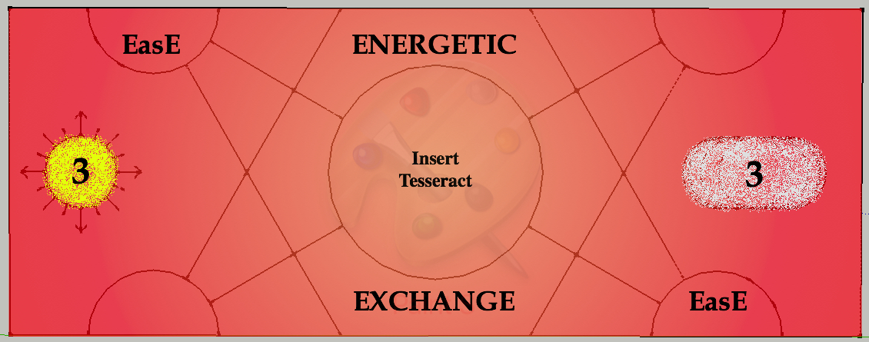
3 Minutes: The Tesseract is representative of the 4th dimension or the mixing of waters.

Reverse Side: Represented by Phytoplankton, a single celled water creature, base of the food chain, produces the majority of oxygen on Earth.
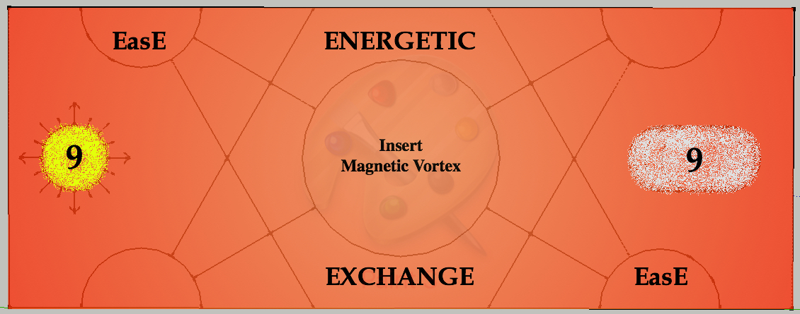

9 Minutes: Magnetic Vortex or Field is representative of Earth and this plane of existence.

Reverse Side: Represented by the Tree of Life, as above so below.

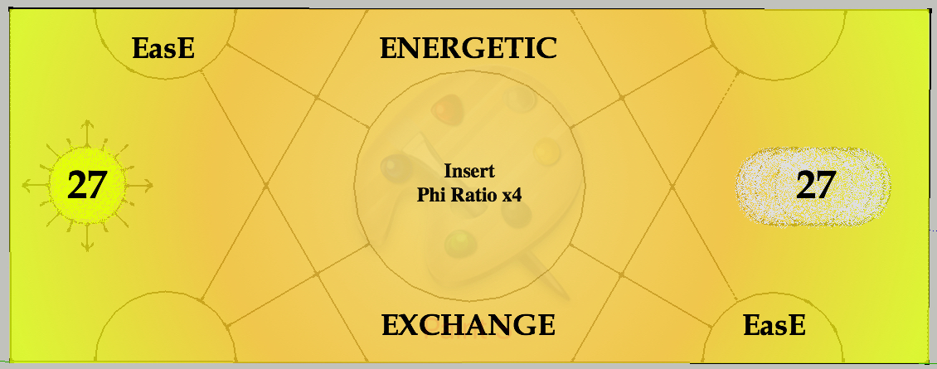

27 Minutes: Golden or Phi Ratio is representative of our ever-expanding consciousness.

Reverse side: Represented by the snail and more specifically the snail’s shell whose design follows the Golden or Phi ratio.
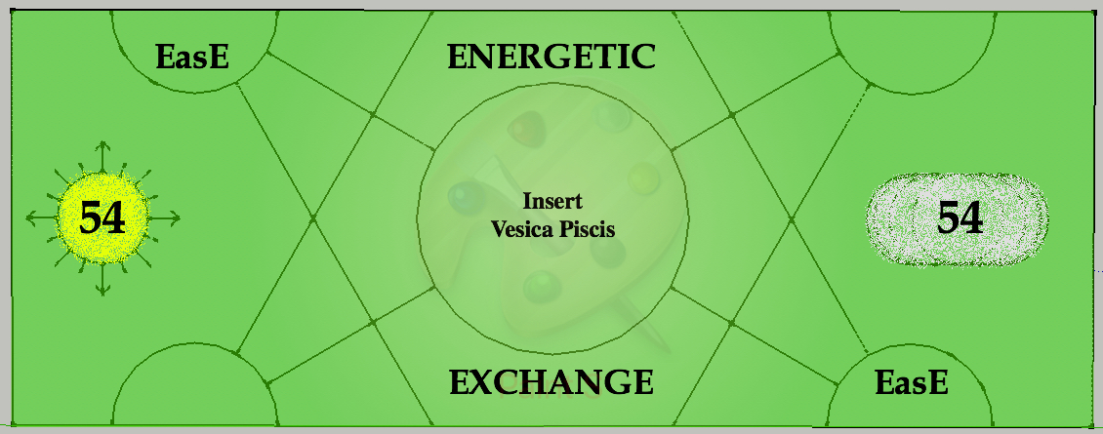

54 Minutes: The Vesica Piscis is representative of two worlds, two ways of being.

Reverse side: Represented by the Fox for it’s cunning and opening of the 3rd eye or meeting place of two worlds, the “Heavens and Earth”.
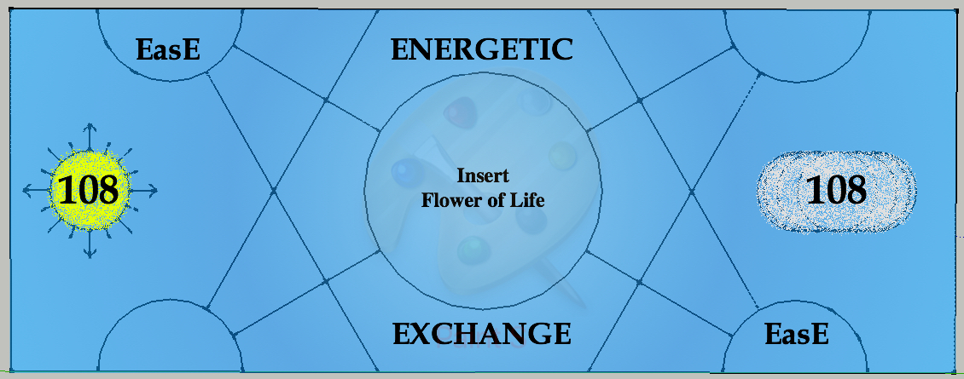

108 Minutes: The Flower of Life is representative of Earth and all life upon it.

Reverse side: Represented by the Sunflower, growing from the Earth, tracking the Sun, endless fractal pattern.

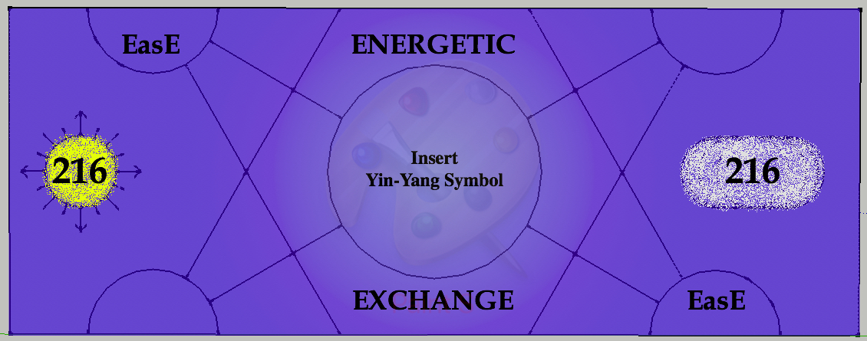
216 Minutes: Yin-Yang is representative of balance, masculine and feminine.

Reverse side: Represented by a cougar and eagle for leadership and action from a higher perspective.

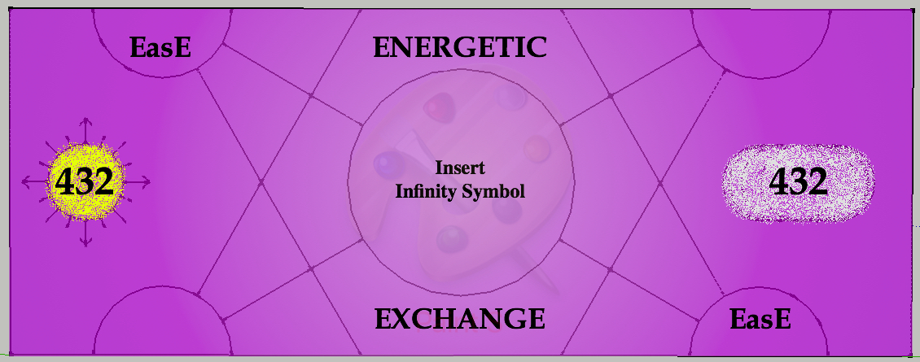
432 Minutes: Infinity is representative of the cycles of life, beginning and end, frequency.

Reverse side: Represented by the Phoenix, born from its own ashes, forever in its own cycle of death and rebirth.

Diving further into the notes we find the sun/directional symbol and moon in its phases where the amount of time in minutes is displayed. The sun/directional symbol is very similar to one I found while looking through images of indigenous pictographs located in Bon Echo Park or Mazinaw Rock. Being a currency based on time it makes sense to incorporate the natural time keeping mechanisms of the sun, moon and stars on these notes.

One of the biggest benefits of this note is its freedom from all forms of taxes, fees and other controls because these notes are based on time and not a fiat currency. They cannot be taxed whether it’s a sales tax, payroll deduction or other forms of taxes and/or fees applied to payroll. Because of this these notes will also be worth more where they are accepted because the hold their whole value without deductions. As an example, a 13-month calendar produced by one of Talking Trees Community projects may cost $10.00 Canadian because taxes would have to be charged and all the process associated with that type of transaction. This same calendar may cost 9 minutes of EasE or $4.50 Canadian because of the simplicity of the note and its transactions.

These notes are also perfect for North Frontenac in its introduction and application of Contributionism as one of the biggest challenges for the municipality in its creation of the world’s first One Small Township is how contributions can be tracked and taxed. Immediately the idea of taxing a contribution or anything at all feels wrong but I understand the perspective they are coming from and understand this is a transitional step. While everyone working/creating with Talking Trees can receive their energetic exchange (pay) in Canadian dollars, EasE or a combination of both in conjunction with food, temporary housing and fuel, those participating specifically in Contributionism (3 hours a week) will receive a 50/50 exchange of Canadian dollars and EasE for their contribution plus food. This is a wonderfully balanced way to introduce EasE to newcomers and track Contributionism without it being taxed and move away from the conventional time for money system.

For the creation, printing and management of these notes a budget has been included in Talking Trees “Creating the Community” doc that also includes an EasE building. For the initial backing of the note we will use $1 Canadian dollar = 1 minute of EasE (or $1.00 per minute) so anyone wanting to exchange them can do it with ease. There will be no fractional lending here. The initial Canadian funds to back EasE can come from infinite sources but two stand out. In the “Creating the Community” doc there is $1,650,000 in salaries over the first 3 years that could be utilized as backing. Placing the $1,650,000 for salaries in Talking Trees EasE building will allow the creation of 2,300,000 minutes of EasE. There has also been discussion about “no interest loans” to further support/create projects in North Frontenac. Using these loans in place of conventional mortgages for individual residences in the community would be an amazing source of backing for EasE and have the following domino effect. If the average loan for a residential Holistic Home is $200,000 Canadian dollars that would convert into 400,000 minutes of EasE. A conventional mortgage ends up costing more than twice the original loan because of compound interest, so on a $200,000 mortgage you would end up paying over $400,000. The same $200,000 Holistic Home loan with EasE would cost only the original 400,000 minutes plus an administration fee, no more. This allows and encourages the use of EasE as a currency, removes over $200,000 of fiat debt from the individual and the fractional banking system, reduces the cost for the individual(s) building/purchasing their home by over half which in-turn reduces the time they spend paying off the debt and facilitates the beginning of the transition away from fiat fractional banking to true freedom and infinite creation.

As outlined in the beginning of this document, the intention of EasE is as a transitional tool out of the current financial system, its not to replace it.

For Talking Trees, the creation of EasE is to facilitate a transition to a moneyless society, where as a collaborative group of passionate individuals we create a truly Holistic Community where all are free to follow their passions and labours of love to create a life of joy and abundance. A foundational belief of “do no harm, cause no loss” integrated with Holistic Homes and businesses that encounter earth’s natural phenomenon to provide all utilities and life support systems makes every aspect of this Holistic Development beyond sustainable. For those seeking change this blueprint for Holistic Community design can be replicated almost anywhere in the world helping create communities of abundance for generations to come.

The best way to describe what this may look and feel like is a blending of the ancient social and organizational structures of many indigenous tribes with the modern amenities of today.

So, I guess I have just one question…

How would you like to pay for that?

With EasE

